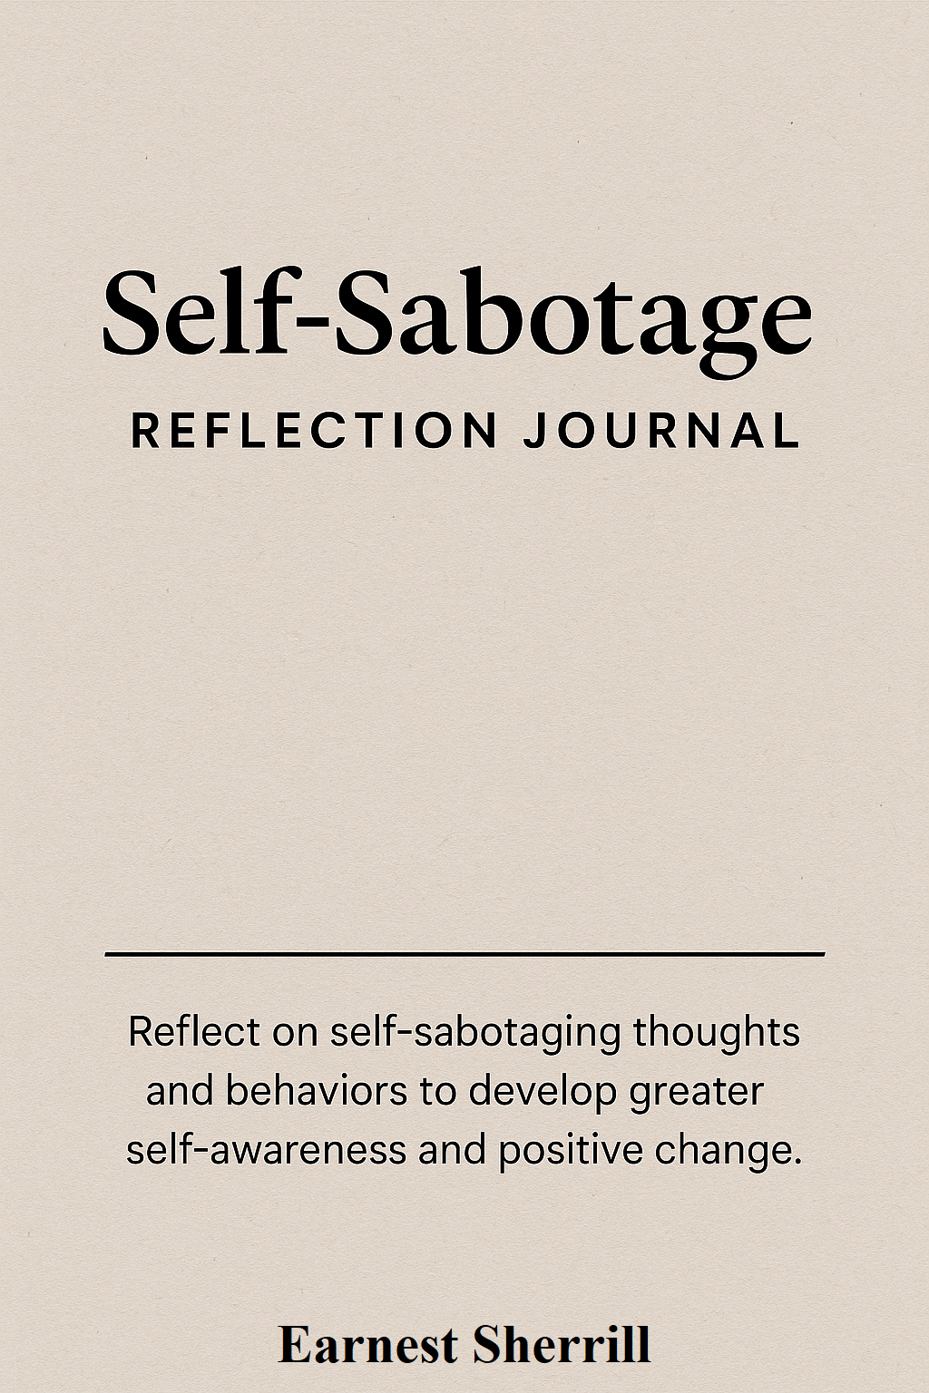

Self-Sabotage Reflection Journal (Monthly)
Welcome to your Self-Sabotage Reflection Journal. This space is designed to help you become more aware of your self-sabotaging behaviors, understand their roots, and practice healthier, more compassionate actions. Use this journal daily or weekly to track patterns, thoughts, and progress.
The Self-Sabotage Reflection Journal is more than just a collection of questions on a page it’s a soft place to land when you’re feeling stuck, overwhelmed, or frustrated with yourself. This journal invites you to slow down and really listen to what’s going on inside, without judgment. It helps you peel back the layers of fear, self-doubt, and old habits so you can start responding to life in a way that reflects your true self, not your survival instincts.
Each entry walks you through a thoughtful, compassionate process: What triggered you? How did you respond? What story did your inner critic tell you? And, most importantly, how can you respond with kindness and courage next time?
It’s not about fixing yourself because you’re not broken. It’s about learning how to support yourself better. Bit by bit, page by page, this journal helps you build a more trusting, loving relationship with the person who matters most: you.

Reflection Entry 1
Date: ______________________________
1. What happened today that triggered feelings of stress, fear, or overwhelm?

2. What did I do in response? (e.g., procrastinate, avoid, overwork, self-criticize)

3. What was I thinking at the time? What did my inner critic say?

4. What emotion was I feeling underneath the surface? (e.g., fear, shame, sadness)

5. What would a compassionate response look like?

6. One small action I can take next time:

Reflection Entry 2
Date: ______________________________
1. What happened today that triggered feelings of stress, fear, or overwhelm?

2. What did I do in response? (e.g., procrastinate, avoid, overwork, self-criticize)

3. What was I thinking at the time? What did my inner critic say?

4. What emotion was I feeling underneath the surface? (e.g., fear, shame, sadness)

5. What would a compassionate response look like?

6. One small action I can take next time:

Reflection Entry 3
Date: ______________________________
1. What happened today that triggered feelings of stress, fear, or overwhelm?

2. What did I do in response? (e.g., procrastinate, avoid, overwork, self-criticize)

3. What was I thinking at the time? What did my inner critic say?

4. What emotion was I feeling underneath the surface? (e.g., fear, shame, sadness)

5. What would a compassionate response look like?

6. One small action I can take next time:

Reflection Entry 4
Date: ______________________________
1. What happened today that triggered feelings of stress, fear, or overwhelm?

2. What did I do in response? (e.g., procrastinate, avoid, overwork, self-criticize)

3. What was I thinking at the time? What did my inner critic say?

4. What emotion was I feeling underneath the surface? (e.g., fear, shame, sadness)

5. What would a compassionate response look like?

6. One small action I can take next time:

Reflection Entry 5
Date: ______________________________
1. What happened today that triggered feelings of stress, fear, or overwhelm?

2. What did I do in response? (e.g., procrastinate, avoid, overwork, self-criticize)

3. What was I thinking at the time? What did my inner critic say?

4. What emotion was I feeling underneath the surface? (e.g., fear, shame, sadness)

5. What would a compassionate response look like?

6. One small action I can take next time:

Reflection Entry 6
Date: ______________________________
1. What happened today that triggered feelings of stress, fear, or overwhelm?

2. What did I do in response? (e.g., procrastinate, avoid, overwork, self-criticize)

3. What was I thinking at the time? What did my inner critic say?

4. What emotion was I feeling underneath the surface? (e.g., fear, shame, sadness)

5. What would a compassionate response look like?

6. One small action I can take next time:

Reflection Entry 7
Date: ______________________________
1. What happened today that triggered feelings of stress, fear, or overwhelm?

2. What did I do in response? (e.g., procrastinate, avoid, overwork, self-criticize)

3. What was I thinking at the time? What did my inner critic say?

4. What emotion was I feeling underneath the surface? (e.g., fear, shame, sadness)

5. What would a compassionate response look like?

6. One small action I can take next time:

Reflection Entry 8
Date: ______________________________
1. What happened today that triggered feelings of stress, fear, or overwhelm?

2. What did I do in response? (e.g., procrastinate, avoid, overwork, self-criticize)

3. What was I thinking at the time? What did my inner critic say?

4. What emotion was I feeling underneath the surface? (e.g., fear, shame, sadness)

5. What would a compassionate response look like?

6. One small action I can take next time:

Reflection Entry 9
Date: ______________________________
1. What happened today that triggered feelings of stress, fear, or overwhelm?

2. What did I do in response? (e.g., procrastinate, avoid, overwork, self-criticize)

3. What was I thinking at the time? What did my inner critic say?

4. What emotion was I feeling underneath the surface? (e.g., fear, shame, sadness)

5. What would a compassionate response look like?

6. One small action I can take next time:

Reflection Entry 10
Date: ______________________________
1. What happened today that triggered feelings of stress, fear, or overwhelm?

2. What did I do in response? (e.g., procrastinate, avoid, overwork, self-criticize)

3. What was I thinking at the time? What did my inner critic say?

4. What emotion was I feeling underneath the surface? (e.g., fear, shame, sadness)

5. What would a compassionate response look like?

6. One small action I can take next time:

Reflection Entry 11
Date: ______________________________
1. What happened today that triggered feelings of stress, fear, or overwhelm?

2. What did I do in response? (e.g., procrastinate, avoid, overwork, self-criticize)

3. What was I thinking at the time? What did my inner critic say?

4. What emotion was I feeling underneath the surface? (e.g., fear, shame, sadness)

5. What would a compassionate response look like?

6. One small action I can take next time:

Reflection Entry 12
Date: ______________________________
1. What happened today that triggered feelings of stress, fear, or overwhelm?

2. What did I do in response? (e.g., procrastinate, avoid, overwork, self-criticize)

3. What was I thinking at the time? What did my inner critic say?

4. What emotion was I feeling underneath the surface? (e.g., fear, shame, sadness)

5. What would a compassionate response look like?

6. One small action I can take next time:

Reflection Entry 13
Date: ______________________________
1. What happened today that triggered feelings of stress, fear, or overwhelm?

2. What did I do in response? (e.g., procrastinate, avoid, overwork, self-criticize)

3. What was I thinking at the time? What did my inner critic say?

4. What emotion was I feeling underneath the surface? (e.g., fear, shame, sadness)

5. What would a compassionate response look like?

6. One small action I can take next time:

Reflection Entry 14
Date: ______________________________
1. What happened today that triggered feelings of stress, fear, or overwhelm?

2. What did I do in response? (e.g., procrastinate, avoid, overwork, self-criticize)

3. What was I thinking at the time? What did my inner critic say?

4. What emotion was I feeling underneath the surface? (e.g., fear, shame, sadness)

5. What would a compassionate response look like?

6. One small action I can take next time:

Reflection Entry 15
Date: ______________________________
1. What happened today that triggered feelings of stress, fear, or overwhelm?

2. What did I do in response? (e.g., procrastinate, avoid, overwork, self-criticize)

3. What was I thinking at the time? What did my inner critic say?

4. What emotion was I feeling underneath the surface? (e.g., fear, shame, sadness)

5. What would a compassionate response look like?

6. One small action I can take next time:

Reflection Entry 16
Date: ______________________________
1. What happened today that triggered feelings of stress, fear, or overwhelm?

2. What did I do in response? (e.g., procrastinate, avoid, overwork, self-criticize)

3. What was I thinking at the time? What did my inner critic say?

4. What emotion was I feeling underneath the surface? (e.g., fear, shame, sadness)

5. What would a compassionate response look like?

6. One small action I can take next time:

Reflection Entry 17
Date: ______________________________
1. What happened today that triggered feelings of stress, fear, or overwhelm?

2. What did I do in response? (e.g., procrastinate, avoid, overwork, self-criticize)

3. What was I thinking at the time? What did my inner critic say?

4. What emotion was I feeling underneath the surface? (e.g., fear, shame, sadness)

5. What would a compassionate response look like?

6. One small action I can take next time:

Reflection Entry 18
Date: ______________________________
1. What happened today that triggered feelings of stress, fear, or overwhelm?

2. What did I do in response? (e.g., procrastinate, avoid, overwork, self-criticize)

3. What was I thinking at the time? What did my inner critic say?

4. What emotion was I feeling underneath the surface? (e.g., fear, shame, sadness)

5. What would a compassionate response look like?

6. One small action I can take next time:

Reflection Entry 19
Date: ______________________________
1. What happened today that triggered feelings of stress, fear, or overwhelm?

2. What did I do in response? (e.g., procrastinate, avoid, overwork, self-criticize)

3. What was I thinking at the time? What did my inner critic say?

4. What emotion was I feeling underneath the surface? (e.g., fear, shame, sadness)

5. What would a compassionate response look like?

6. One small action I can take next time:

Reflection Entry 20
Date: ______________________________
1. What happened today that triggered feelings of stress, fear, or overwhelm?

2. What did I do in response? (e.g., procrastinate, avoid, overwork, self-criticize)

3. What was I thinking at the time? What did my inner critic say?

4. What emotion was I feeling underneath the surface? (e.g., fear, shame, sadness)

5. What would a compassionate response look like?

6. One small action I can take next time:

Reflection Entry 21
Date: ______________________________
1. What happened today that triggered feelings of stress, fear, or overwhelm?

2. What did I do in response? (e.g., procrastinate, avoid, overwork, self-criticize)

3. What was I thinking at the time? What did my inner critic say?

4. What emotion was I feeling underneath the surface? (e.g., fear, shame, sadness)

5. What would a compassionate response look like?

6. One small action I can take next time:

Reflection Entry 22
Date: ______________________________
1. What happened today that triggered feelings of stress, fear, or overwhelm?

2. What did I do in response? (e.g., procrastinate, avoid, overwork, self-criticize)

3. What was I thinking at the time? What did my inner critic say?

4. What emotion was I feeling underneath the surface? (e.g., fear, shame, sadness)

5. What would a compassionate response look like?

6. One small action I can take next time:

Reflection Entry 23
Date: ______________________________
1. What happened today that triggered feelings of stress, fear, or overwhelm?

2. What did I do in response? (e.g., procrastinate, avoid, overwork, self-criticize)

3. What was I thinking at the time? What did my inner critic say?

4. What emotion was I feeling underneath the surface? (e.g., fear, shame, sadness)

5. What would a compassionate response look like?

6. One small action I can take next time:

Reflection Entry 24
Date: ______________________________
1. What happened today that triggered feelings of stress, fear, or overwhelm?

2. What did I do in response? (e.g., procrastinate, avoid, overwork, self-criticize)

3. What was I thinking at the time? What did my inner critic say?

4. What emotion was I feeling underneath the surface? (e.g., fear, shame, sadness)

5. What would a compassionate response look like?

6. One small action I can take next time:

Reflection Entry 25
Date: ______________________________
1. What happened today that triggered feelings of stress, fear, or overwhelm?

2. What did I do in response? (e.g., procrastinate, avoid, overwork, self-criticize)

3. What was I thinking at the time? What did my inner critic say?

4. What emotion was I feeling underneath the surface? (e.g., fear, shame, sadness)

5. What would a compassionate response look like?

6. One small action I can take next time:

Reflection Entry 26
Date: ______________________________
1. What happened today that triggered feelings of stress, fear, or overwhelm?

2. What did I do in response? (e.g., procrastinate, avoid, overwork, self-criticize)

3. What was I thinking at the time? What did my inner critic say?

4. What emotion was I feeling underneath the surface? (e.g., fear, shame, sadness)

5. What would a compassionate response look like?

6. One small action I can take next time:

Reflection Entry 27
Date: ______________________________
1. What happened today that triggered feelings of stress, fear, or overwhelm?

2. What did I do in response? (e.g., procrastinate, avoid, overwork, self-criticize)

3. What was I thinking at the time? What did my inner critic say?

4. What emotion was I feeling underneath the surface? (e.g., fear, shame, sadness)

5. What would a compassionate response look like?

6. One small action I can take next time:

Reflection Entry 28
Date: ______________________________
1. What happened today that triggered feelings of stress, fear, or overwhelm?

2. What did I do in response? (e.g., procrastinate, avoid, overwork, self-criticize)

3. What was I thinking at the time? What did my inner critic say?

4. What emotion was I feeling underneath the surface? (e.g., fear, shame, sadness)

5. What would a compassionate response look like?

6. One small action I can take next time:

Reflection Entry 29
Date: ______________________________
1. What happened today that triggered feelings of stress, fear, or overwhelm?

2. What did I do in response? (e.g., procrastinate, avoid, overwork, self-criticize)

3. What was I thinking at the time? What did my inner critic say?

4. What emotion was I feeling underneath the surface? (e.g., fear, shame, sadness)

5. What would a compassionate response look like?

6. One small action I can take next time:

Reflection Entry 30
Date: ______________________________
1. What happened today that triggered feelings of stress, fear, or overwhelm?

2. What did I do in response? (e.g., procrastinate, avoid, overwork, self-criticize)

3. What was I thinking at the time? What did my inner critic say?

4. What emotion was I feeling underneath the surface? (e.g., fear, shame, sadness)

5. What would a compassionate response look like?

6. One small action I can take next time:

Reflection Entry 31
Date: ______________________________
1. What happened today that triggered feelings of stress, fear, or overwhelm?

2. What did I do in response? (e.g., procrastinate, avoid, overwork, self-criticize)

3. What was I thinking at the time? What did my inner critic say?

4. What emotion was I feeling underneath the surface? (e.g., fear, shame, sadness)

5. What would a compassionate response look like?

6. One small action I can take next time:

Reflection Entry 32
Date: ______________________________
1. What happened today that triggered feelings of stress, fear, or overwhelm?

2. What did I do in response? (e.g., procrastinate, avoid, overwork, self-criticize)

3. What was I thinking at the time? What did my inner critic say?

4. What emotion was I feeling underneath the surface? (e.g., fear, shame, sadness)

5. What would a compassionate response look like?

6. One small action I can take next time:

Reflection Entry 33
Date: ______________________________
1. What happened today that triggered feelings of stress, fear, or overwhelm?

2. What did I do in response? (e.g., procrastinate, avoid, overwork, self-criticize)

3. What was I thinking at the time? What did my inner critic say?

4. What emotion was I feeling underneath the surface? (e.g., fear, shame, sadness)

5. What would a compassionate response look like?

6. One small action I can take next time:

Reflection Entry 34
Date: ______________________________
1. What happened today that triggered feelings of stress, fear, or overwhelm?

2. What did I do in response? (e.g., procrastinate, avoid, overwork, self-criticize)

3. What was I thinking at the time? What did my inner critic say?

4. What emotion was I feeling underneath the surface? (e.g., fear, shame, sadness)

5. What would a compassionate response look like?

6. One small action I can take next time:

Reflection Entry 35
Date: ______________________________
1. What happened today that triggered feelings of stress, fear, or overwhelm?

2. What did I do in response? (e.g., procrastinate, avoid, overwork, self-criticize)

3. What was I thinking at the time? What did my inner critic say?

4. What emotion was I feeling underneath the surface? (e.g., fear, shame, sadness)

5. What would a compassionate response look like?

6. One small action I can take next time:

